**APPLICATION CONTAINERIZATION**

**LAB EXPERIMENT 3**

**SUBMITTED BY:**

NITISH KUMAR SINGLA

500071913

R171218126

**SUBMITTED TO:**

HITESH KUMAR SHARMA SIR

**Docker Network**

$docker network ls – to see the list of networks created

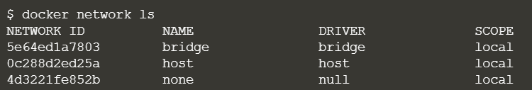

$docker network create network1 – create a network



$docker ps - to see the running containers and $docker ps -a – to see all the running and terminated containers

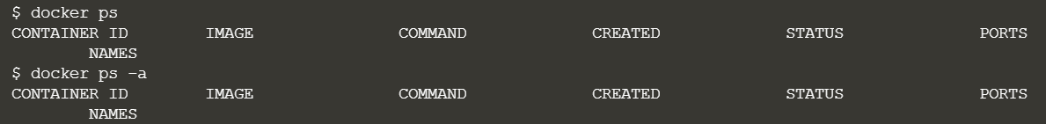

$docker run -d –name=container1 –net=network1 redis



Docker run –name=container2 –net=network1 alpine ping container1

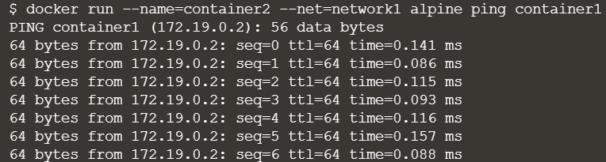

$docker network create network2



$docker network connect network2 container1



$docker network disconnect network2 container1

